Project Part A
Nur Afiqah – 60306981
Zahra Al - Waili – 60307052

Task 1:
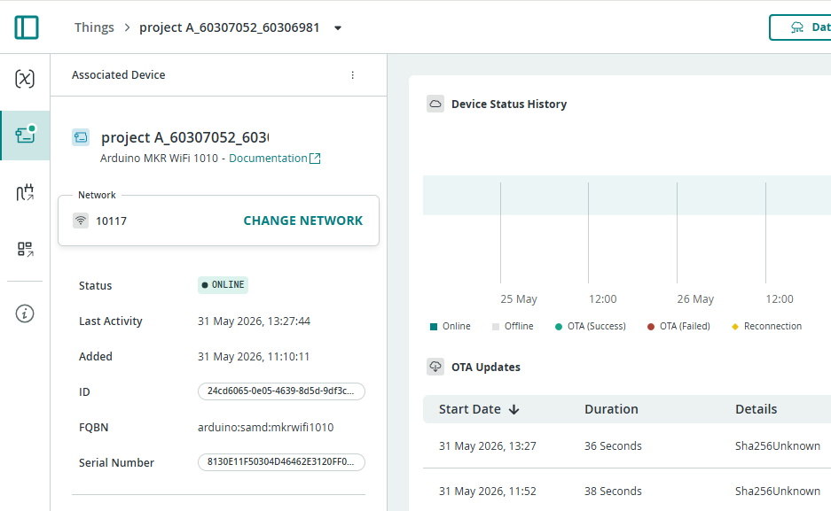
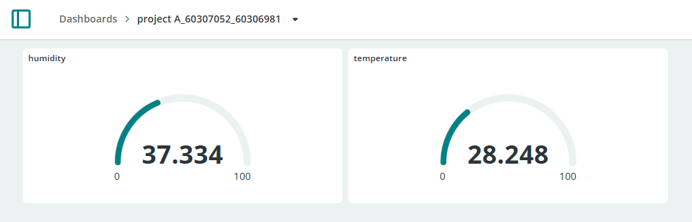
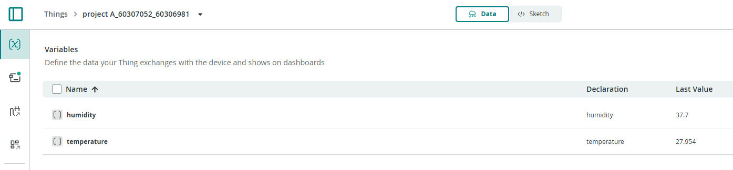

Task 2:
